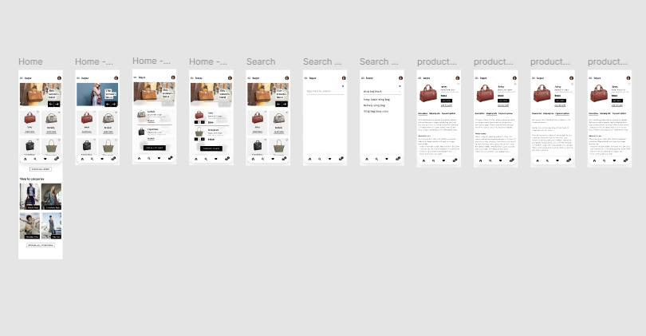
EX 3. E-COMMERCE APP PROTOTYPE

